**POSTAL SERVICES DATA MANAGEMENT SYSTEM**

DATABASE PROJECT REPORT

**SUBMITTED BY**

|  |  |
| --- | --- |
| **Name:** Anuritha L | **USN:** 1MS21AD012 |
| **Name:** Shubhangi | **USN:** 1MS21AD048 |
| **Name:** Yashashwini Singh | **USN:** 1MS21AD061 |
|  |  |

As part of the Course **Database Systems– AD32**

SUPERVISED BY

Faculty

**VINAY T R**

ASSISTANT PROFESSOR

DEPARTMENT OFAI and DS



DEPARTMENT OF ARTIFICIAL INTELLIGENCE AND DATA SCIENCE

RAMAIAH INSTITUTE OF TECHNOLOGY

NOV 2022 – FEB 2023



Department of Artificial Intelligence and Data Science

Ramaiah Institute of Technology

(Autonomous Institute, Affiliated to VTU)

Bangalore – 54

**CERTIFICATE**

This is to certify that **Name: (USN:)**, **Name: (USN:)** have completed the **“<Project TOPIC>”** as part of Database Project. We declare that the entire content embodied in this B.E. 5th Semester report contents are not plagiarized.

Submitted by Guided by

|  |  |
| --- | --- |
| Name: Anuritha L | USN: 1MS21AD012 |
| Name: Shubhangi | USN: 1MS21AD048 |
| Name: Yashashwini Singh | USN: 1MS21AD061 |
|  |  |

Vinay T R

(Dept of AIDS, RIT) (Assistant Professor, Dept. of CSE, RIT)

Department of Artificial Intelligence and Data Science

Ramaiah Institute of Technology

(Autonomous Institute, Affiliated to VTU)

Bangalore – 54



**Evaluation Sheet**

|  |  |  |  |  |  |
| --- | --- | --- | --- | --- | --- |
| **Sl. No** | **USN** | **Name** | **Research Content understanding**  **and Coding**  **(10)** | **Demo & Report submission**  **(10)** | **Total Marks**  **(20)** |
| **1.** | **1MS21AD012** | ANURITHA L |  |  |  |
| **2.** | **1MS21AD048** | SHUBHANGI |  |  |  |
| **3.** | **1MS21AD061** | YASHASHWINI SINGH |  |  |  |
|  |  |  |  |  |  |

Evaluated By

(Vinay T R)

Assistant Professor

AIDS, RIT

**CONTENTS**

|  |  |  |
| --- | --- | --- |
| **Sl. No.** | **TITLE** | **Page no** |
| **1.** | **Content’s Abstract** |  |
| **2.** | **Introduction** |  |
| **4.** | **Background, Motivation and Scope** |  |
| **5.** | **Methodology** |  |
| **7.** | **Requirements** |  |
| **8.** | **E-R Diagram** |  |
| **9.** | **Relational Database Design** |  |
| **10.** | **Database Normalization** |  |
| **11.** | **Source Code** |  |
| **12.** | **Output Snapshots** |  |
| **13.** | **Conclusion** |  |

**ABSTRACT**

Post offices deal with humongous amount of data on a daily basis. They cater various services like delivering envelopes, inland letters, parcels, post office bank and pension accounts. Speedy and efficient information processing is crucial to our socially and highly developed technology. Computer can help the intolerable burden of handling the ever increasing amount or information with government department, public services and business concerns expected to contain because of their ability to analyze information as well as to retain, update and reproduce it because of their versality to present it in a variety of forms. This may also to some extent lead to problems occurring due to information explosion.

Using PostgreSQL, this project aims to organize daily information created by postal services department, it contains Employee, Department, Item, Status of Delivery and Branch details of all Post offices in a city. This aims to reduce redundancy of tuples in the database and establishes ease of access.

**INTRODUCTION**

POST OFFICE works in every walk of our life. Through the automation of this system one can easily generate the information about the customer available and also about the old records. For this efficient software the first and the foremost thing is that all the requirements should be known before hand and the developer should devote its effort for the completion of that requirement which are demanded by the customer should be fulfilled. This system can be used in various education departments and can distribute the copies of the system among the management and staff members for the required information of their customer.

This very handy project for any user and includes following features: -

* Having customer information and total amount payable
* For the help of user it displays each and status of delivery.
* Maintains all the old record for future reference.

The e-Post Office is the shopping portal of the world-renowned postal service on the Internet and an additional distribution channel. It sells Stamps, Postcards, Packets, and Cartons and has services like courier, registering for electricity vendors, selling mobile cards, etc.  Under this website many products and services can be ordered, that are also available in a "normal" branch.  The product prices are identical with the prices of their normal branches.  The e-Post Office is expanded permanently through new products and services in order to offer a product portfolio corresponding to the market.  Private customer and business customers can order the selected products of the postal service online quickly and comfortably. For the case of the absence or the move, one can let delegate here the after shipment of the postal service at another address or store the letter shipments.  The customers can register themselves and can be served individually.

**BACKGROUND**

The existing postal services network is inefficient when it comes to ease of access of the data, it is a manual system which needs to be converted into automated system. There is always a risk of mismanagement of data as well as lesser security. There is no proper coordination between different Applications and Users. There are fewer users and accuracy is not guaranteed.

**MOTIVATION**

There are various deficiencies in the manual system of keeping postal records such as the following,

* **Lack of immediate retrieval of information -** In manual system, lot of time is wasted in retrieving information. Much searching is required before required is found. This wastes a lot of time of the user as well as the person.
* **Lack of immediate information storage –** In manual system, it is difficult to store information at proper place at that very moment. This is because the person is unable to quickly locate the place where the information is to be stored.
* **Prompts updating not possible –** Changes are quite natural in all walks of life. Information and stored data also changes from time to time. These changes should be incorporated in the working also to keep the information up to date. However, bringing about changes through the manual system is a slow and tedious process because of which inaccurate information storage occurs.
* **Unplanned working –** The manual system lacks the element of planned working. Records are not properly maintained. This creates a lot of problems at times like during information retrieval and storage.
* **Accuracy –** The manual system lacks accuracy in working and a number of operations may be performed incorrectly, the computations that are done in the organization may be incorrect and whatever is generated in the system may be inaccurate.
* **Reliability –** The reliability of the manual system is considered to be low because of the above given reasons including the fact that ‘TO error is human’. Any task that is performed by men, always contain the risk of errors.
* **Redundancy of information –** In manual system, particular information may be stored at a number of places, lending to redundancy. Redundancy of data or information creates a number of problems storage space is wasted; changes at one place are to be made at a number of places and so on.

Due to these reasons, there arises a need to create an efficient database to organize Postal data which will help government services to handle the Post Services in a highly professional manner and improve the service offered to the citizens.

**SCOPE**

1. **Immediate retrieval of information –** The main objective of the new system is to provide for quick and efficient retrieval of information, any type of information would be available to the user whenever he requires. Facility would be provided for online query to cut down on the response time greatly.
2. **Immediate storage of information –** In the proposed system, it will be easy to store information at any given time at the correct places. The location of storage would be easily available and user will face no difficulty.
3. **Prompt updating of information –** In the proposed system, the information will always remain up to date as the updating will be prompt and without any efforts. This factor will be of great importance in the proposed system as it determines the integrity of the information stored.
4. **Fast computation of information –** The computation of information will be quite fast in the proposed system. Not only mathematical calculations, but also logical comparisons will be quick in the new system.
5. **Planned approach toward working –** The working is the service center information system will be well planned and organized. The data will be stored properly in the data store, which will help in retrieval of information as well as in its storage.
6. **Accuracy –** The level of accuracy in the new proposed system would be higher. All operations and computations would be done correctly and this will ensure that whatever information is coming from the center, it is accurate.
7. **Reliability –** The reliability of the proposed system would be high due to the above stated reasons. The reason for the increased reliability of the system is that now there would be proper storage of information, its maintenance would be well managed and retrieval would be possible in the desired manner.
8. **Non-Redundant Information –** In the new system, utmost care be taken that no information is repeated, any usage of storage or otherwise. This would assure economic usage of storage or space and consistency in the data stored. This will also help make those changes easily as the change would have to be made only at that very place and no where else.

**METHODOLOGY**

The Methodology that will be required for the creation and development of a full fledged working database for Postal Services of India is as follows.

1. SURVEY **-** It begins with a request from the user for a new system. It involves the following:
   * Identify the responsible user for a new system
   * Clarify the user request
   * Identify deficiencies in the current system
   * Establish goals and objectives of new system
   * Determine the feasibility for new system
   * Prepare the project charter which will guide about the remainder of the project
2. SYSTEM ANALYSIS **–** The objective of the system analysis activity is to develop structured system specification for the proposed system. The structured system specification should describe what the proposed system would do; independent of the technology, which will be used to implement these requirements. The structured system specification will be called the essential model (also known as logical model). The essential model may itself consist of multiple models, modeling different aspect of the system. Generally three models used for such purpose are: -
   * DATA FLOW DIAGRAM (DFD) **–** It models the functioning of the system. DFD may consist of following
3. Context diagram
4. Leveled Data Flow Diagram
5. Process specification for Elementary Bubble
6. Data dictionary for the flows and stores on the DFD

* ENTITY RELATIONSHIP DIAGRAM **–** It models the functioning of the data and their relationship.
* STATE TRANSITION DIAGRAM **–** It models the time dependent behavior of the system.

1. PRELIMINARY DESIGN – This activity deals with certain design issues, which are to be finalized in consultation with user. The two most common design issues of relevance to the user are the automation boundary and the human machine interface. The output of the activity is the user implementation model. The major part of the user implementation model is the specification for the user interface of the proposed system. The user implementation model is also referred to as the physical model of the proposed system. The model, in addition to the essential model, defines the following for the proposed system:
2. Automation boundary
3. Report layouts
4. Layouts of the source documents
5. Screen Layouts for the data entry form
6. Menu
7. SYSTEM DESIGN**–** System design involves transformation of the user implementation model into software design. The design specifications of the proposed system consist of mainly database schema.
8. IMPLEMENTATION **–** This activity includes programming, testing and integration of modules into a progressively more complete system.
9. ACCEPTANCE TEST GENERATION **–** This activity generates a set of data that can be used to test the new system before accepting it.
10. QUALITY ASSURANCE **–** Assurance is also known as final testing. This activity requires, as its input acceptance test data generated in acceptance test generation and an integrated system produced by implementation.

**REQUIREMENTS**

Following are the technical resources required for developing the system.

HARDWARE REQUIREMENTS:

* PC 512GB & above with 4GB hard disk.
* RAM capacity of minimum of 16GB
* External hard drive 4GB or more
* Epson stylus COLOR 480

# SOFTWARE REQUIREMENTS*:*

* Windows 11 Environment or Ubuntu Linux
* PostGreSQL
* Python 3.10 64 bit for GUI, if required

 OTHER REQUIREMENTS:

* Power Backup
* Memory Backup
* Stationary
* Miscellaneous assets.

# SECURITY REQUIREMENTS:

            Security measures present unauthorized to access the system. Any system to have a security measure should is provided with login-id and password facility. Security is provided for both the database level and application level. Only the authorized persons can avoid the data corruption to accessed database. The database can be accessed only of correct login-id and password is provided.

SOFTWARE CONFIGURATION

* GUI- Tkinter library installed in Python 3.10
* OPERATING SYSTEM- Windows 11 or Ubuntu Linux or MacOS
* BACKEND- PostGreSQL or MySQL or SQL

HARDWARE CONFIGURATION

* A personal computer.
* An SVGA or better Display System.
* 32 MB of variable memory.
* 256 KB of external Cache Memory.
* A 8-16GB Disk Drive.
* A 4.3 GB Hard Disk.
* An Inkjet or Dot Matrix Printer.
* A Microsoft mouse or a compatible pointing device.

**ABOUT POSTGRESQL**

PostgreSQL is an open-source relational database management system (DBMS) developed by a worldwide team of volunteers. PostgreSQL is not controlled by any corporation or other private entity and the source code is available free of charge.

## *Key Features of PostgreSQL*

## PostgreSQL runs on all major operating systems, including Linux, UNIX (AIX, BSD, HP-UX, SGI IRIX, Mac OS X, Solaris, Tru64), and Windows. It supports text, images, sounds, and video, and includes programming interfaces for C / C++, Java, Perl, Python, Ruby, Tcl and Open Database Connectivity (ODBC).

## PostgreSQL supports a large part of the SQL standard and offers many modern features including the following −

* Complex SQL queries
* SQL Sub-selects
* Foreign keys
* Trigger
* Views
* Transactions
* Multiversion concurrency control (MVCC)
* Streaming Replication (as of 9.0)
* Hot Standby (as of 9.0)

## *Procedural Languages Support*

## PostgreSQL supports four standard procedural languages, which allows the users to write their own code in any of the languages and it can be executed by PostgreSQL database server. These procedural languages are - PL/pgSQL, PL/Tcl, PL/Perl and PL/Python. Besides, other non-standard procedural languages like PL/PHP, PL/V8, PL/Ruby, PL/Java, etc., are also supported.

**ENTITY RELATIONSHIP DIAGRAM**

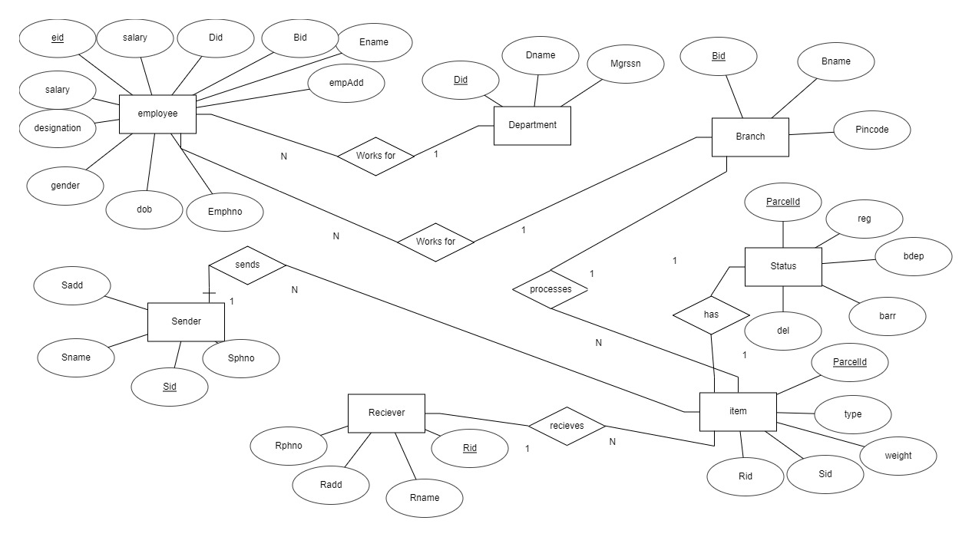

**RELATIONAL DATABASE DESIGN**

***Database Description***

1. Department

* Primary Key- Did varchar(10) (Department ID)
* Dname- varchar(200) (Department Name)
* Mgrssn- varchar(10)

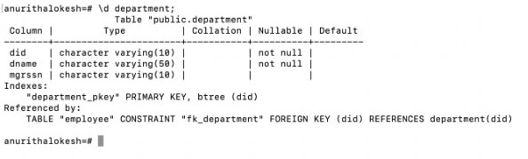

2. Employee

* Primary Key- Eid varchar(10) (Employee ID)
* Foreign Key 1- Bid varchar(10) (Branch ID) referenced by Branch table
* Foreign Key 2- Did varchar(10) (Department ID) referenced by Department table
* Ename- varchar(50) (Employee Name)
* Empadd- varchar(200) (Employee Address)
* Dob- date (Date of Birth)
* Gender- char(10)
* Designation- char(50)
* Salary- Decimal(10,2)
* Emphno- integer

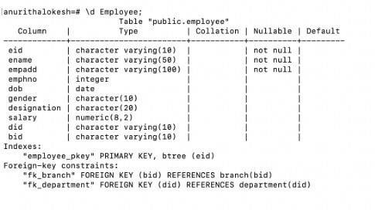

3. Branch

* Primary Key- Bid varchar(10) (Branch ID)
* Bname- varchar(50) (Branch Name)
* Pincode- integer

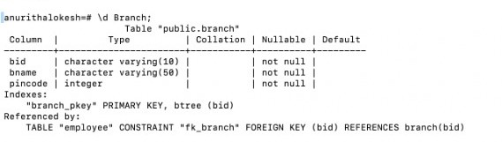

4. Item

* Primary Key- parcelid varchar(10)
* Type- char(50)
* Weight- Numeric(5,2)
* Sid- varchar(10) (Sender’s ID)
* Rid- varchar(10) (Receiver’s ID)

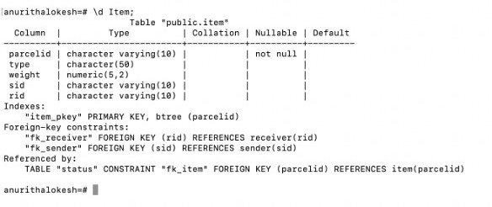

5. Receiver

* Primary key- Rid varchar(10) (Receiver’s ID)
* Rname- varchar(50) (Receiver’s Name)
* Rpho- integer (Receiver’s Phone)
* Radd- varchar(200) (Receiver’s Address)

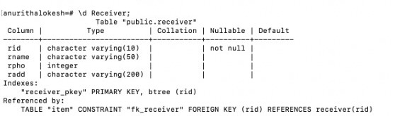

6. Sender

* Primary Key- Sid varchar(10) (Sender’s ID)
* Sname- varchar(50) (Sender’s Name)
* Spho- integer (Sender’s Phone no)
* Sadd- varchar(200) (Sender’s Address)

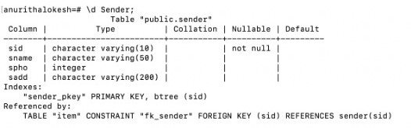

7. Status

* Primary Key- parcelid varchar(10)
* Foreign Key- parcelid referenced from Item Table
* Reg- date (Date of Item Registry)
* Bdep- date (Date of departure from Branch)
* Barr- date (Date of arrival in Branch)
* Del- date (Date of Item Delivery)

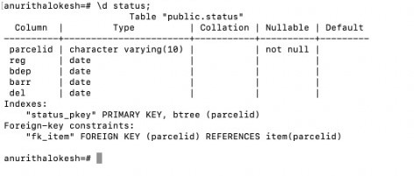

***Schema Diagram***

Employee

|  |  |  |  |  |  |  |  |  |  |
| --- | --- | --- | --- | --- | --- | --- | --- | --- | --- |
| Eid | Bid | Did | Ename | Empadd | Empho | dob | designation | salary | gender |

Branch Department

|  |  |  |
| --- | --- | --- |
| Did | Dname | Mgrssn |

|  |  |  |
| --- | --- | --- |
| Bid | Bname | Pincode |

Item

|  |  |  |  |  |
| --- | --- | --- | --- | --- |
| ParcelID | Type | Weight | Rid | Sid |

Receiver Sender

|  |  |  |  |
| --- | --- | --- | --- |
| Rid | Rname | Rpho | Radd |

|  |  |  |  |
| --- | --- | --- | --- |
| Sid | Sname | Spho | Sadd |

Status

|  |  |  |  |  |
| --- | --- | --- | --- | --- |
| ParcelId | Reg | Bdep | Barr | Del |

|  |  |
| --- | --- |
| Parent Table | Child Table |
| Employee | Receiver |
| Item | Sender |
|  | Status |
|  | Branch |
|  | Department |
|  |  |

**DATABASE NORMALIZATION**

1. FIRST NORMAL FORM

A relation is said to be in 1 normal form in DBMS (or 1NF) when it consists of an atomic value. In simpler words, 1NF states that a table's attribute would not be able to hold various values- it will only be able to hold an attribute of a single value.

Since all the attributes are atomic in all the seven tables of this database, The relation is in first normal form.

2. SECOND NORMAL FORM

A relation that is in First Normal Form and every non-primary-key attribute is fully functionally dependent on the primary key, then the relation is in Second Normal Form (2NF).

Status- S1 Item-I Employee-E Department-D Branch-B Sender-S2 Reciever-R

{SIEDBSR}+={S1,I,E,D,B,S2,R}

{EI}+={B,D,R,S1,S2,E,I} This shows that EI is a super key.

{E}+={B,D} (Not super key)

{I}+={R,S1,S2} (Not super key)

This means that EI is a candidate key.

EI is the candidate key whose Prime Attributes are E and I whereas Non Prime Attributes are B,D,R,S1,S2. Since every non prime attributes is fully functionally dependent on the primary key. Our relation is in Second Normal Form.

3. THIRD NORMAL FORM

A relation that is in First and Second Normal Form and in which no non-primary-key attribute is transitively dependent on the primary key, then it is in Third Normal Form (3NF).

The Prime Attributes are E and I whereas Non Prime Attributes are B,D,R,S1,S2. As we can see from the schema diagram none of the non prime attributes are dependent on other non prime attributes and the prime attributes do not fall on the right side of any of the functional dependencies. Hence our relation is in Third Normal Form.

**SOURCE CODE**

***1. Creating tables***

1. Branch Table

create table Branch(BId varchar(10) primary key not null,Bname varchar(50) not null,Pincode int not null);

ii. Department Table

create table Department(DId varchar(10) primary key not null,DName varchar(50) not null,Mgrssn varchar(10));

iii. Employee Table

create table Employee(EId varchar(10) primary key not null,Ename varchar(50) not null,EmpAdd varchar(100) not null,Emphno int,DOB date,Gender char(10),Designation char(20),Salary decimal(8,2),DId varchar(10),BId varchar(10),constraint fk_Department foreign key(DId) references Department(DId),constraint fk_Branch foreign key(BId) references Branch(BId));

iv. Sender Table

create table Sender(Sid varchar(10) primary key not null,Sname varchar(50),Spho int,SAdd varchar(200));

v. Receiver Table

create table Receiver(Rid varchar(10) primary key not null,Rname varchar(50),Rpho int,RAdd varchar(200));

vi. Item Table

create table Item(ParcelId varchar(10) primary key not null,Type char(50),Weight decimal(5,2),Sid varchar(10),Rid varchar(10),constraint fk_Sender foreign key(Sid) references Sender(Sid),constraint fk_Receiver foreign key(Rid) references Receiver(Rid));

vii. Status Table

create table Status(ParcelId varchar(10) primary key not null,Reg date,BDep date,Barr date,Del date,constraint fk_Item foreign key(ParcelId) references Item(ParcelId));

***2. Inserting Values***

i. Branch Table

insert into Branch(BId,Bname,Pincode) values ('1KA41BA1JA','Jaynagar',560041);

insert into Branch(BId,Bname,Pincode) values ('1ND01DE2SM','Sansad Marg',110001);

insert into Branch(BId,Bname,Pincode) values ('1TN17CH3TN','T Nagar',600017);

insert into Branch(BId,Bname,Pincode) values ('1MH08MU4KA','Kamathipura',400008);

insert into Branch(BId,Bname,Pincode) values ('1WB16KO5PS','Park Street',700016);

insert into Branch(BId,Bname,Pincode) values ('1AP04HY6KH','Khairatabad',500004);

insert into Branch(BId,Bname,Pincode) values (‘1UP01AG7MR’,’Mall Road',282001);

insert into Branch(BId,Bname,Pincode) values ('1AS14GU8GO','Gopinath Bordoloi Nagar',781014);

insert into Branch(BId,Bname,Pincode) values ('1GU09AH9NA','Navrangpura',380009);

ii. Department Table

insert into Department values('ID001','Information Department','1KA01ID001');

insert into Department values('SP002','Speed Post & Couriour','1TN02SP002');

insert into Department values('TR003','Transportation','1UP03TR003');

iii. Item Table

insert into item values('VG254H','Speed Post',0.25,'XG450T','PK560D');

insert into item values('HG254H','Courier',5.6,'AG450T','IK560D');

insert into item values('BG254H','Post Card',0.20,'RG450T','RK560D');

insert into item values('CG254H','BookPacket',3.00,'SG450T','ZK560D');

insert into item values('WG254H','Newsletter',1.00,'TG450T','DK560D');

iv. Status Table

insert into status values('VG254H','2022-09-12','2022-09-13','2022-09-15','2022-09-16');

insert into status values('HG254H','2022-10-12','2022-10-13','2022-10-15','2022-10-16');

insert into status values('BG254H','2022-11-12','2022-11-13','2022-11-15','2022-11-16');

insert into status values('CG254H','2022-12-12','2022-12-13','2022-12-15','2022-12-16');

insert into status values('WG254H','2023-01-12','2023-01-13','2023-01-15','2023-01-16');

v. Employee Table

insert into Employee values('1KA01ID001','Joytha Kumar','No.379 Addam Williams lane Shantinagar,Karnataka-560012’,78988640,'1984-12-06','Female','Director',100000.00,'ID001','1KA41BA1JA');

insert into Employee values('1TN02SP002','Prathap Singh','No.379Williams lane Shantinagar,Tamilnadu 560017',88988640,'1994-11-06','Male','Supervisor',450000.00,'SP002','1TN17CH3TN');

insert into Employee values('1UP03TR003','Reddy Naidu','No.39 Xaviers lane UP 110017',78988640,'2004-11-07','Male','Transport Manager',350000.00,'TR003', ‘1UP01AG7MR’);

insert into Employee values('1UP03TR003','Rajesh Kumar','No.79 Shantiketan nagar UP 110012',78988640,'1994-11-07','Male','Transport Manager',400000.00,'TR003','1UP01AG7MR');

insert into Employee values('1ND01ID001','Rajeswari Kumari','No.9 Dutchmen street Nagaland 210012',68988640,'2004-01-05','Female','Admin',150000.00,'ID001','1ND01DE2SM');

insert into Employee values('1MH05SP002','Ram Verma','No.9 Saroj lane Maharashtra 710012',58988640,'2000-07-08','Male','Postman',80000.00,'SP002','1MH08MU4KA');

vi. Sender Table

insert into sender values('XG450T','Rahul Verma',767656,'No 476 Shantiviwas Street Kolkata 170045');

insert into sender values('AG450T','Kajal Dhingra',867656,'No 46 Xavier Street Kolkata 150047');

insert into sender values('RG450T','Aghastya Shah',767656,'No 6 Mughlai Street Delhi 180057');

insert into sender values('SG450T','Shriya Srinivas',767656,'No 16 Shalininagar Ahmedabadh 230057');

insert into sender values('TG450T','Alvin Zaid',267656,'No 15 Sultan nagar Lucknow 930057');

vii. Receiver Table

insert into receiver values('PK560D','Akul Balaji',7867656,'No 187 Vijay nagar Banglore 630057');

insert into receiver values('IK560D','Kiran Kumar',8867656,'No 987 Chamrajpet Mysore 670057');

insert into receiver values('RK560D','Raj Singh',5867656,'No 87 Itnagar Gawhati 670057');

insert into receiver values('ZK560D','Shaina Talvar',1867656,'No 807 Jamnagar Srinagar 670057');

insert into receiver values('DK560D','Udaideep Amar Prathap Singh',4867656,'No 7 Shamnagar Udaipur 870057');

**OUTPUT SNAPSHOTS**

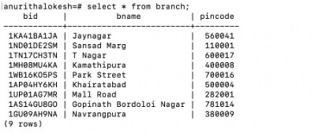

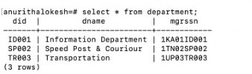

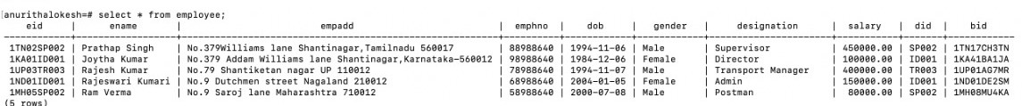

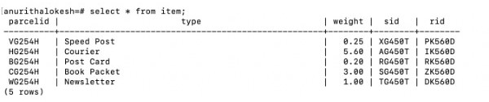

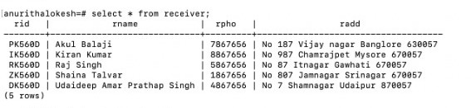

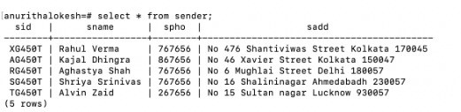

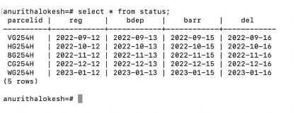

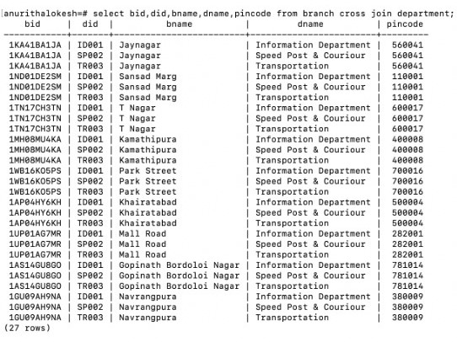

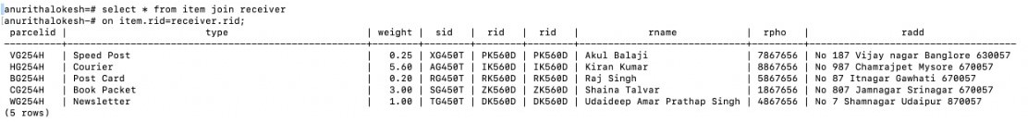

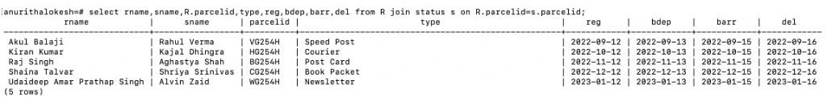

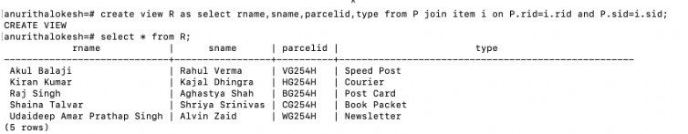

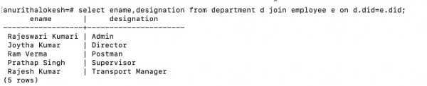

**CONCLUSION**

In conclusion, the Post office database management system project has successfully demonstrated the potential of PostgreSQL in automating and digitizing the various tasks involved in managing a Post office. The system has proved to be user friendly and efficient, and has helped staff working in Postal services to manage the post office's resources and services more effectively. The use of PostgreSQL has enabled the system to store and manipulate large amounts of data, and to generate useful insights from that data. The Post office Database Management System is much more user-friendly, faster in operation  
and easy to manage than the manual one. Through it, the staff in a post office can manage the whole data of the Office in a single database in different tables with much more security than the traditional way. Overall, the Post Office database management system has been a success, and it is likely that it will continue to be used and improved upon in the future. The use of PostgreSQL has proven to be a valuable tool in this project, and it is likely that it will continue to be an important component of database management systems in the years to come. With the increase in the workload in the Post Office, new features can be added to the existing application to make it relevant in the future as well.